React + Tailwind + RSBuild Setup

Table of Contents

1.0 Prerequisites 3
2.0 React Setup 3
3.0 Tailwind Setup 5
4.0 RSBuild Setup 8
5.0 Add Font Family 10
6.0 Additional Enterprise Tooling Requirements 12
6.1 TypeScript 12
6.2 Jest 12
6.3 Cypress 13
6.4 Prettier 13
7.0 Git Hub 14
7.1 Branch Protection Rule 14
7.2 Making Pull Request 15
7.3 Errors 17

1.0 Prerequisites
Download Node.js: Node.js — Download Node.js®

2.0 React Setup
In Visual Studio Code Terminal
Enter this command :
npm create vite@latest my-react-tailwind -- --template react

This command will tell the npm to create a new Vite project
- ‘my-react-tailwind' is the name of the project
- ‘--template react’ specifies that we want to set up a React template

After running the command, Vite will create the project and download the necessary files.
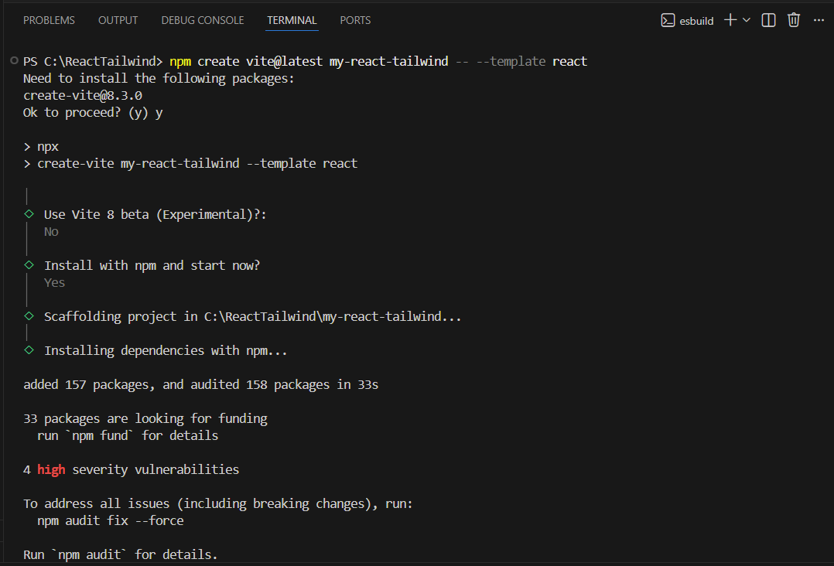
Figure 1

As shown in Figure 2, Vite has successfully created the React project and the development server is running.
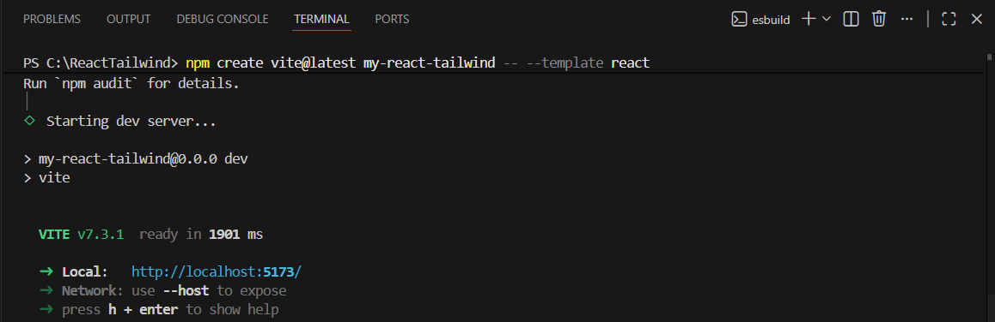
Figure 2

3.0 Tailwind Setup
Enter this command:
npm install -D tailwindcss postcss autoprefixer

- To install Tailwind CSS, PostCSS (a Node.js tool for transforming CSS styles with JavaScript plugins), and Autoprefixer (which adds vendor prefixes to CSS rules).
- The ‘-D’ flag installs these packages as development dependencies.

Then create two configuration files (Tailwind and PostCSS) by running this command:
npx tailwindcss init –p

- This command creates a ‘tailwind.config.js’ and a ‘postcss.config.js’ file in the project root.
- Tailwind.config.js is where you can customize the design system
- Postcss.config.js is where Tailwind integrates into the build process

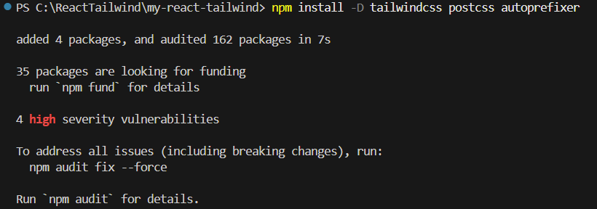
Figure 3

Configure the template path -> Tailwind.config.js
- Open the ‘tailwind.config.js’ file
- Add the content array - inform Tailwind to scan the index file, every source folder and subfolder inside the source folder, and any file under these js, ts, jsx, or tsx extension.
- Ensure Tailwind only includes the styles that the project is using and keep the CSS file lean and fast in production.
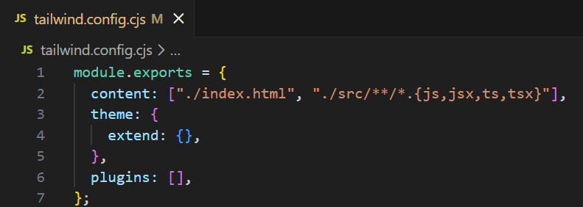
Figure 4
PostCSS is a CSS processing tool that uses plugins (like Tailwind and Autoprefixer) to transform and optimize your styles before they are served to the browser.

Configure postcss.config.js to include Tailwind as a PostCSS plugin. Thie enures Tailwind CSS is processed during build.
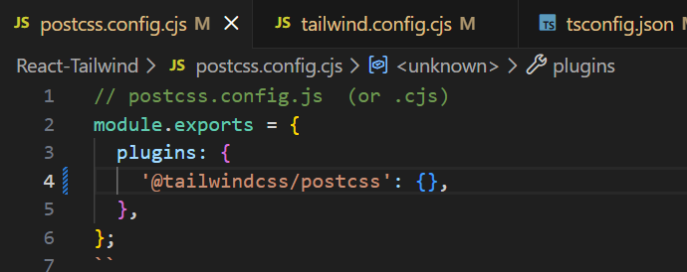
Figure 5

Add Tailwind into the CSS file
Adding these Tailwind directives will import Tailwind’s default styles, reusable components, and utility classes.
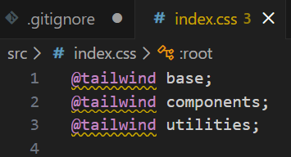
Figure 6

4.0 RSBuild Setup
What is RSBuild?
- RSBuild is a fast and lightweight build tool for JavaScript and TypeScript projects.
- It is designed for simplicity and performance, making it a great choice for React applications.

Enter this command to install Rsbuild:
npm install -D @rsbuild/core @rsbuild/plugin-react

- @rsbuild/core is a core Rsbuild package that provides the CLI commands and JavaScript API
- @rsbuild/plugin-react is an Rsbuild plugin to provide support for React, integrating features such as JSX compilation and React Refresh

Then, create a file named rsbuild.config.js with the configuration as shown in Figure 6.
The following configuration enables:
- React support via @rsbuild/plugin-react.
- Defines where the app starts (./src/main.jsx).
- Specifies where bundles go after building (./dist).
- Sets environment defaults (development for local dev; switch to production to optimize for deploy).

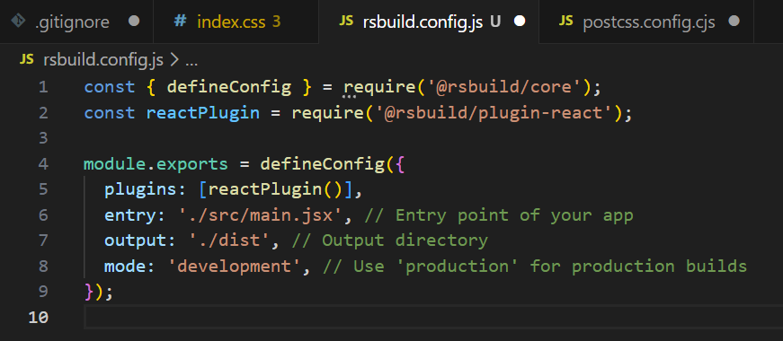
Figure 7
Build scripts are added to package.json to define the commands needed to run the project’s build tools such as starting the development server, compiling code and generating production builds

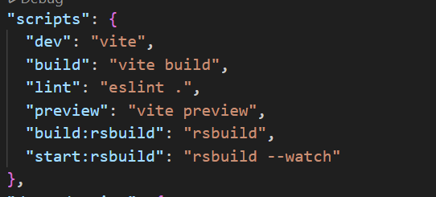
Figure 8

5.0 Add Font Family
Place font family files under folder ‘fonts’ (under ‘assets’)
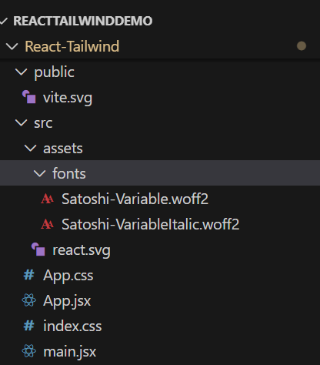
Figure 9

Declare imported fonts in global CSS file, using @font-face. It registers the font so Tailwind and browser can utilise it.
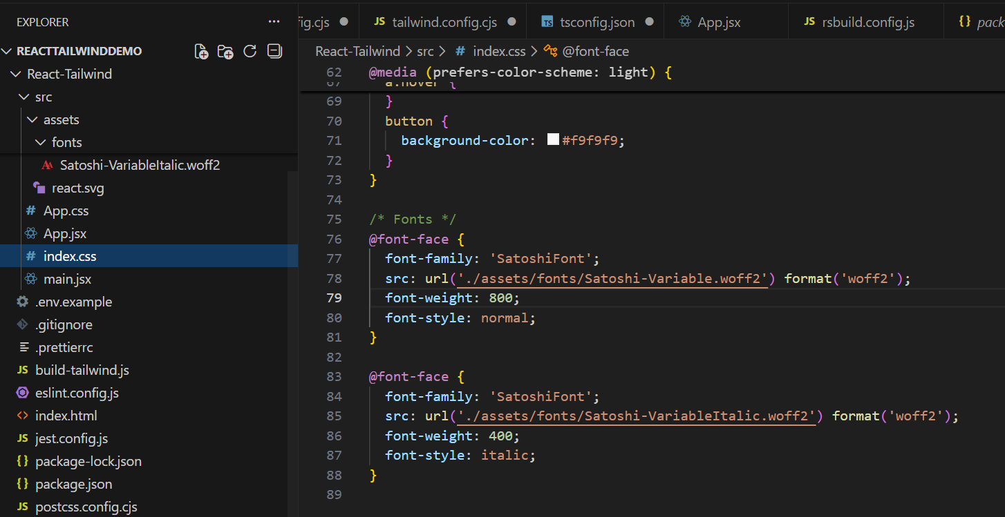
Figure 10

To register font as a tailwind utility class, it is added under theme.extend.fontFamily. This creates a custom class named ‘font-satoshi’.
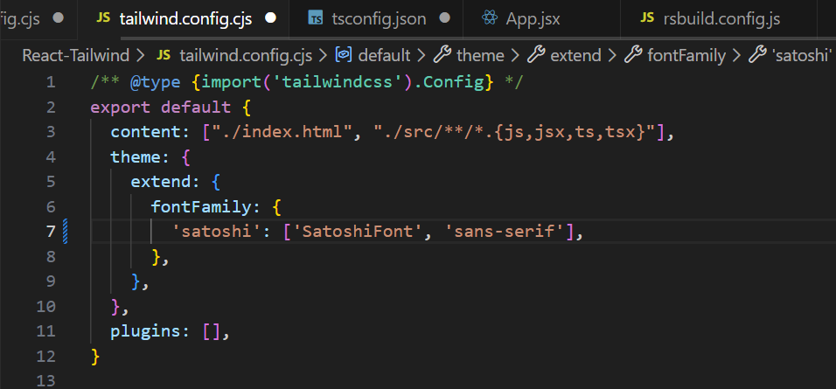
Figure 11

As shown in Figure 11., the font can now be applied the components
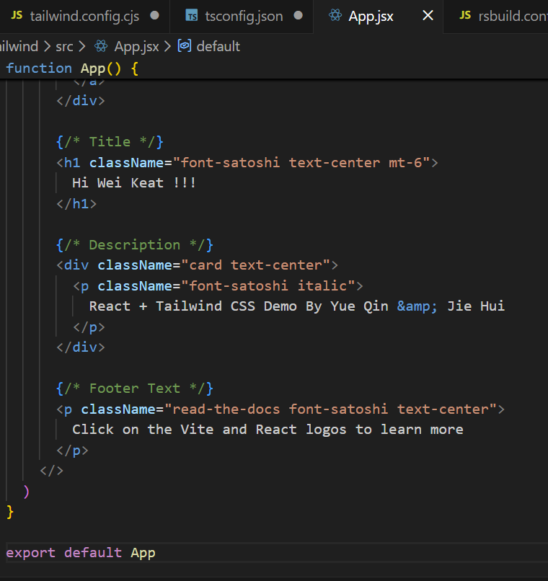
Figure 12

6.0 Additional Enterprise Tooling Requirements

6.1 TypeScript
- A superset of JavaScript that adds static typing, type checking, and improved developer tools.
- Allows developers to define variable, function and component types so errors can be caught before code runs

Add typescript to project:
npm install -D typescript @types/react @types/react-dom

6.2 Jest
A JavaScript testing framework used to run unit tests and ensure individual components and functions behave correctly and consistently.

Enter command to install:
npm install -D jest @testing-library/react @testing-library/jest-dom

@testing-library/jest-dom is a library that provides a set of custom jest matchers that allows to extend jest and make the tests more declarative, clear to read and to maintain.

6.3 Cypress
An end‑to‑end (E2E) testing tool used to simulate real user interactions in the browser, ensuring full user flows work as expected.

Enter command to install:
npm install cypress --save-dev
npx cypress --version

6.4 Prettier
An opinionated code formatter that automatically standardizes code style across the project, improving readability and reducing merge conflicts.

Enter command to install:
npm install -D prettier

7.0 Git Hub

7.1 Branch Protection Rule
- Under settings in the GitHub repository, click on branches
- Click add rule
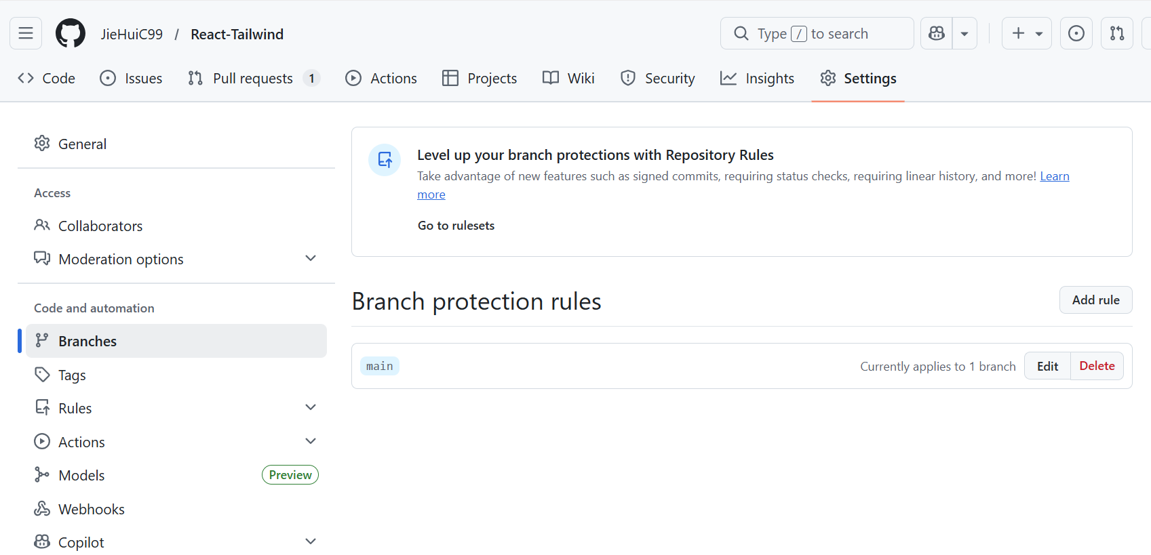
Figure 12
Enter Branch name pattern and select the tickbox ‘Require a pull request before merging’ then click ‘Require approvals’. This will make it so that it requires at least one person’s approval before getting to merge.

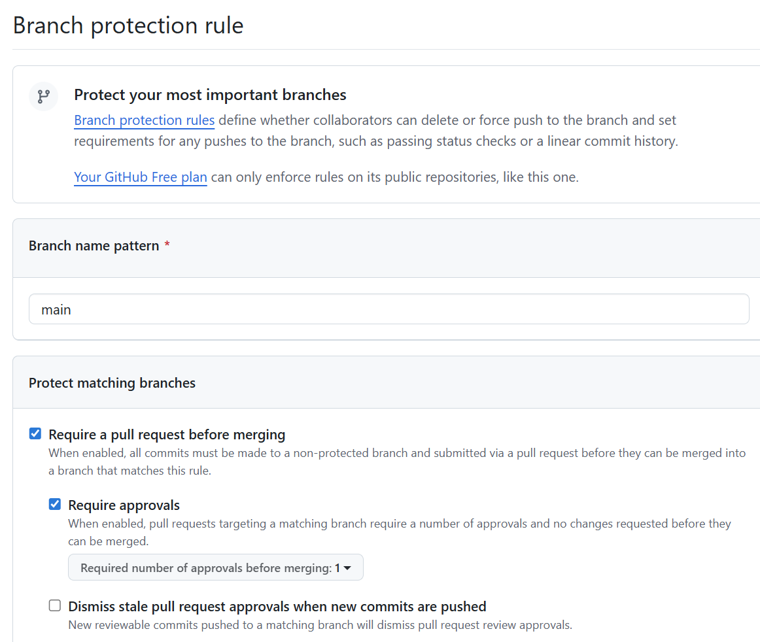
Figure 13

7.2 Making Pull Request
In GitHub when a commit has been made, a create pull request option will appear. The window as shown in Figure 14 will appear, and click ‘Create pull request’
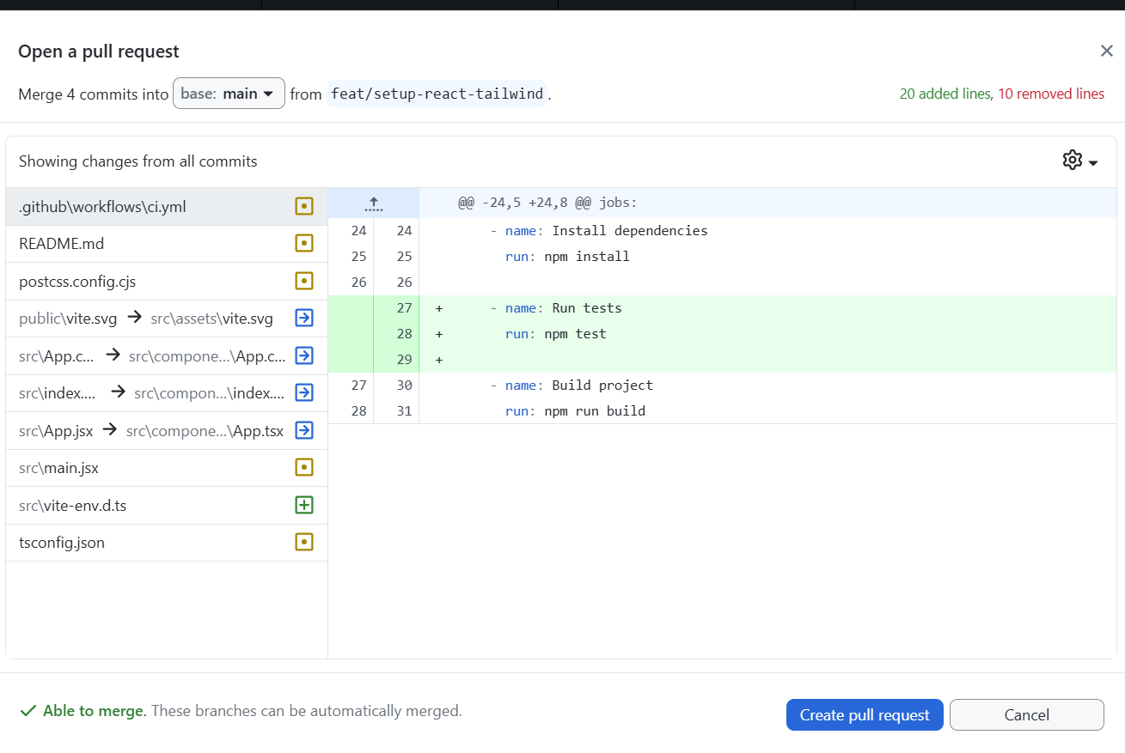
Figure 14
As shown in FIGURE 15, fill in the title and description of pull request and click ‘Create pull request’.
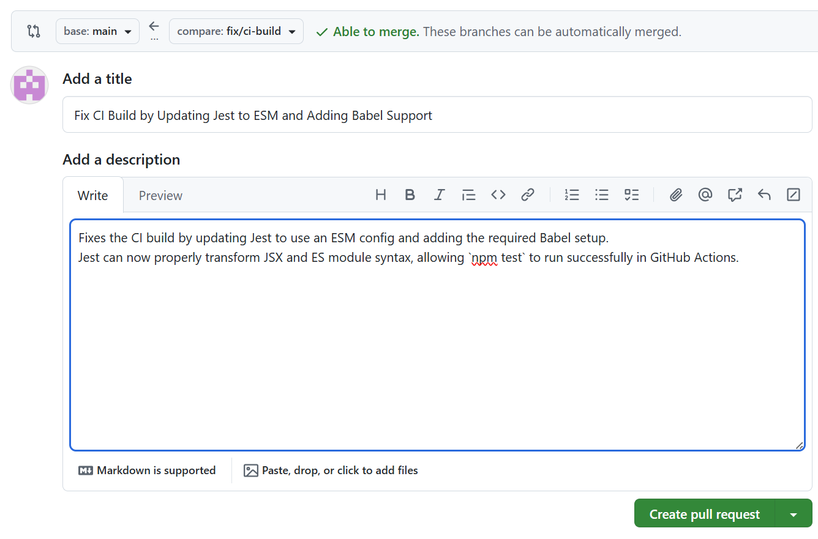
Figure 15
Pull request would be created, and when request is approved and merged. The following window will be shown as in FIGURE16
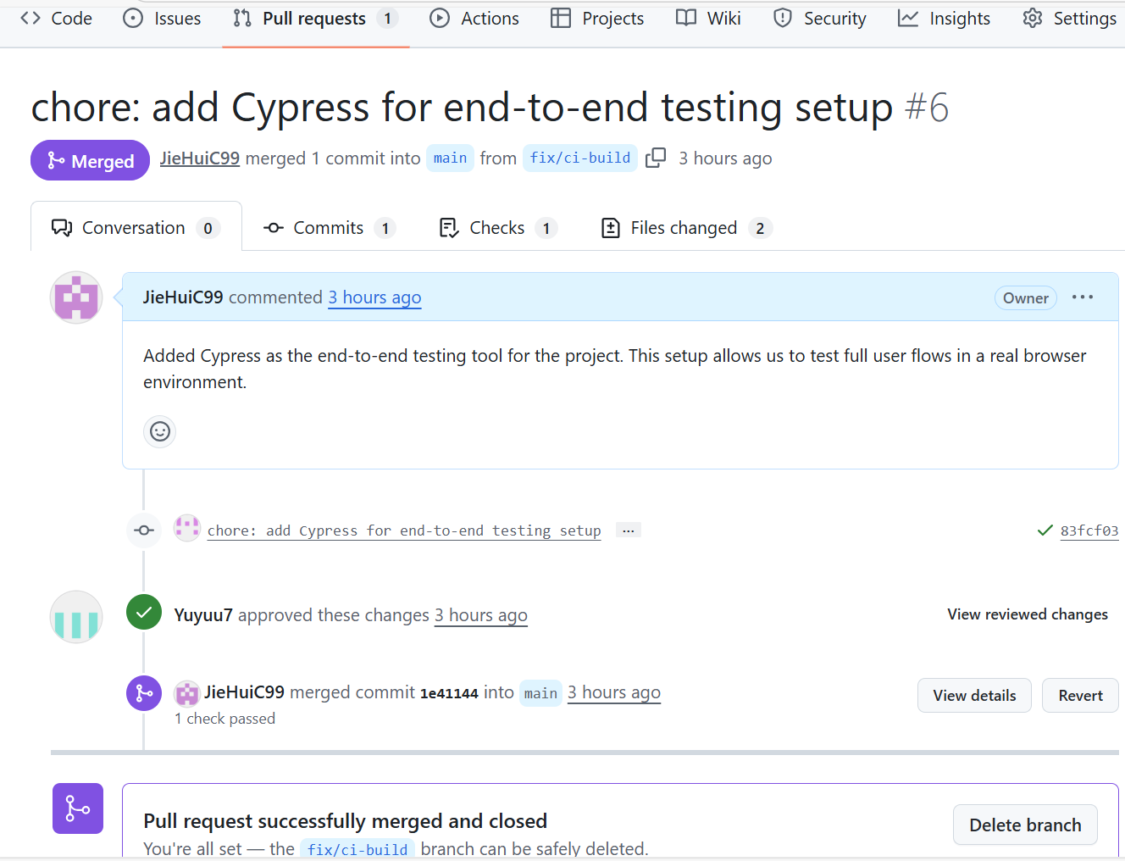
Figure 16

7.3 Errors
Run test error
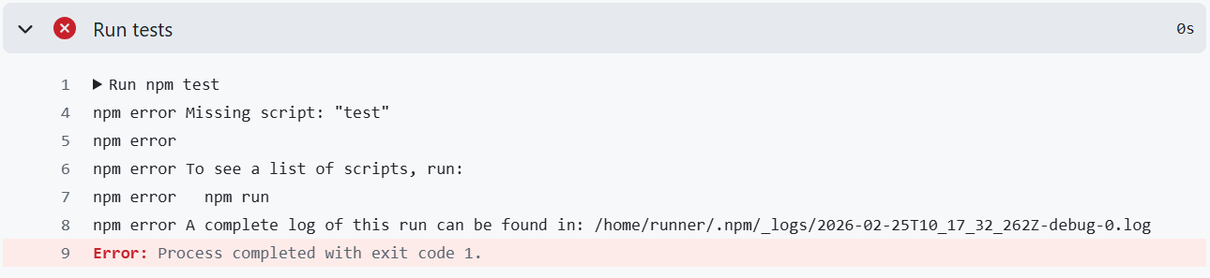
Figure 17
- This error occurs as the CI error came from the npm test which it does not find a test script
- Add test: jest in package json
- Because there was shown that package.json is missing the ‘test’ script
- And adding this test: jest will give a Jest the correct config for TS/React/Vite assets and make the test step run and pass

Migrated Jest to an ESM setup (jest.config.mjs) to match the project’s "type": "module".
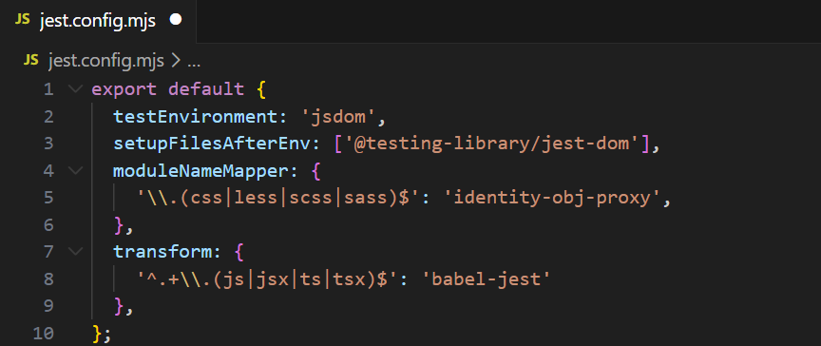
Figure 18

Enter this command:
npm install -D babel-jest @babel/core @babel/preset-react
npm install -D jest-environment-jsdom

This command installs the required tools for Jest to work with React
- @babel/core brings the base of Babel to application
- babel-jest and @babel/preset-react enables the transformation of JavaScript code inside the testing environment, and enable test execution
- jest-environment-jsdom provides JSDOM testing environment, which simulates a DOM environment as if it were in the browser

We added Babel with a minimal babel.config.json so Jest can transform JSX/ESM, and installed jest-environment-jsdom to provide a browser-like DOM for React component test.
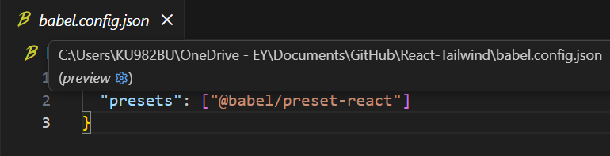
Figure 19

The CI workflow now runs npm test reliably under ESM, and the script uses --passWithNoTests so pipelines don’t fail before tests exist. This gives a clean, stable foundation for adding React tests and scaling coverage.

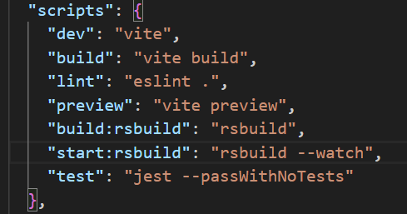
Figure 20

